Practical No 3

Tasks:
- Write a code for the following: (String Operations)
- Reverse a sentence accepted as input by User
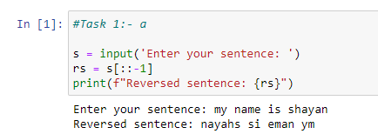
- Find the characters at an odd position in string input by User
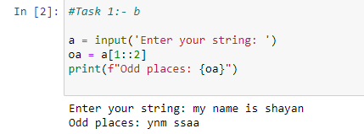
- Check string starts with a specific character entered by the user
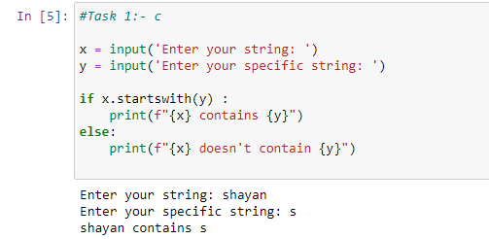
- Remove all newlines from the String
- Replace all occurrence of substring in string
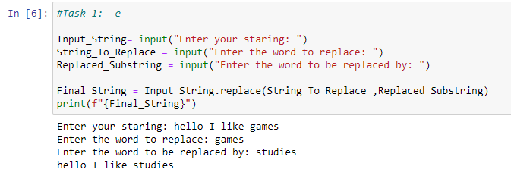
- Remove punctuation mark from list of string
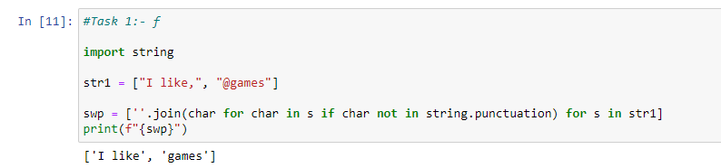
- Find the number of matching characters in two string
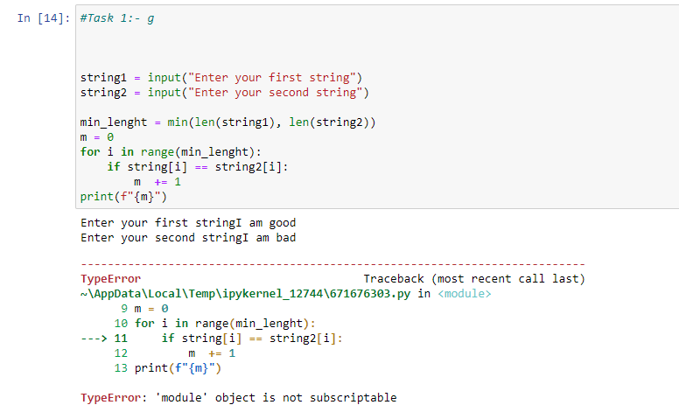
- Convert a string into a list.
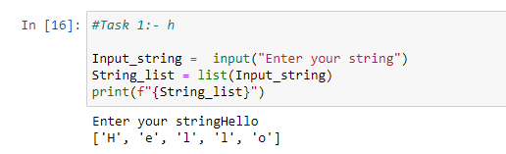
- To convert all string elements of the list to int.
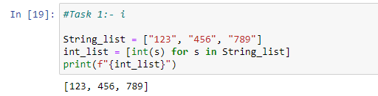
- Count Total numbers of upper case and lower case characters in input string
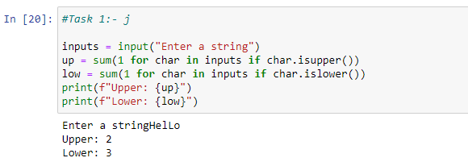
- To find vowels in a string
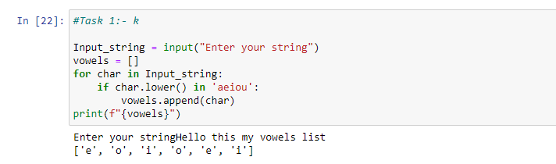
- To sort a list of string in Python
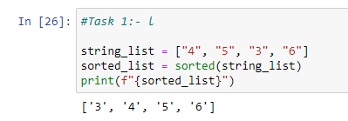
- To print input string in upper case and lower case
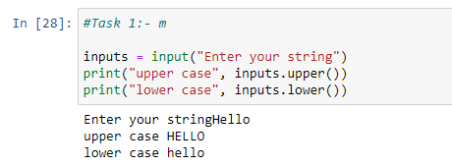
- Convert Int To String In Python
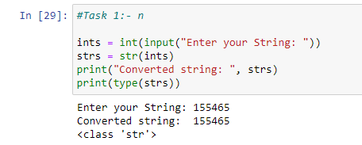
- Write a Python program to accept a string and replace all spaces by ‘#’ symbol.
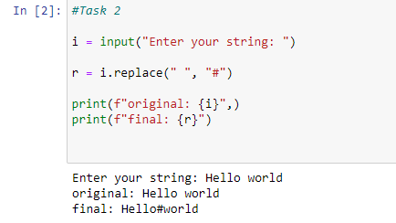
- Write a program to accept two strings from the user and display the common words (ignore case)
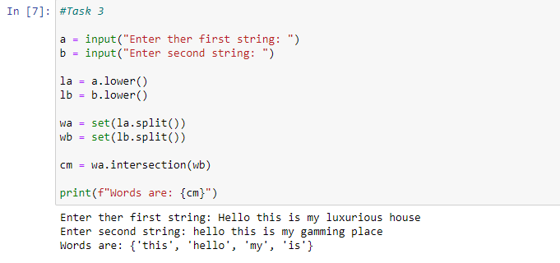
- Write a program to accept a string and count the frequency of each vowel.
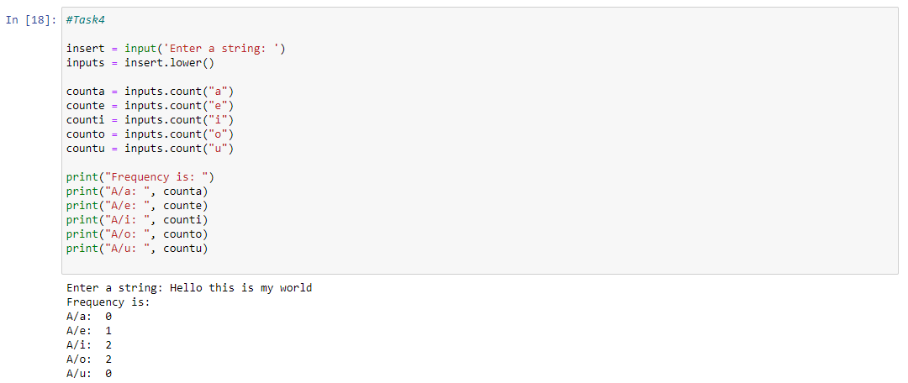
- Create a list in python for storing supermarket bill details and perform the following operations on it:
- Add an item to the end of the list
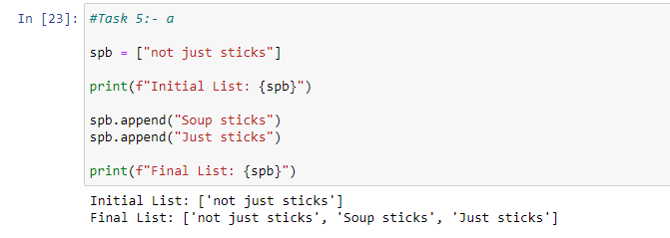
- Insert an item at a given position
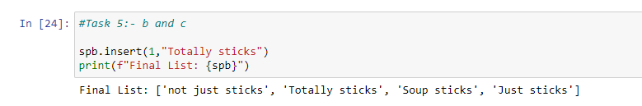
- Modify an element by using the index of the element

- Remove an item from the list
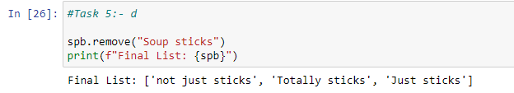
- Remove all items from the list
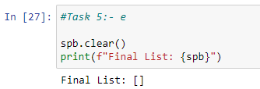
- Slice Elements from a List
- Remove the item at the given position in the list, and return it
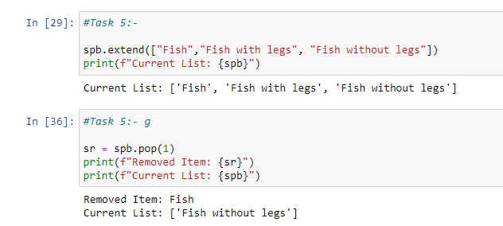
- Return the number of times 'x' appear in the list
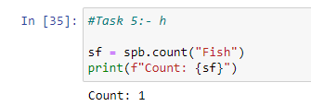
- Sort the items of the list in place
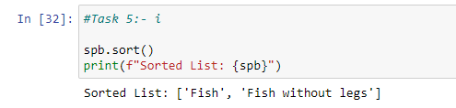
- Reverse the elements of the list in place
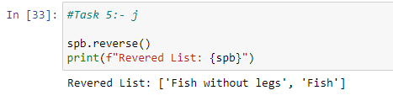
- Write a python program to count unique values inside a list
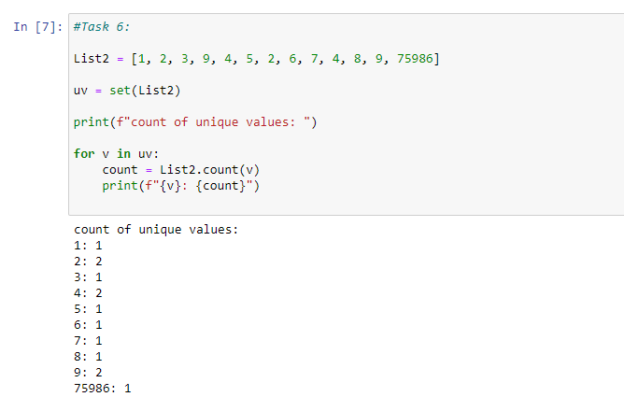
- Write a python program to print a list excluding the duplicates
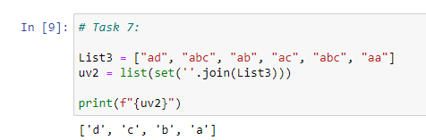
- Write a python program to count positive and negative numbers in a list
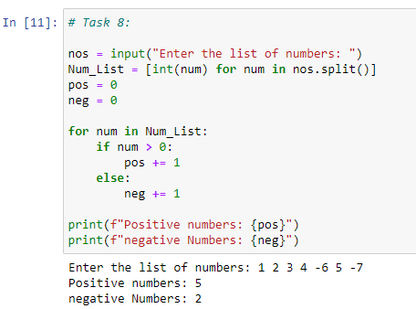
- Write a python program to sum all the elements in a list.
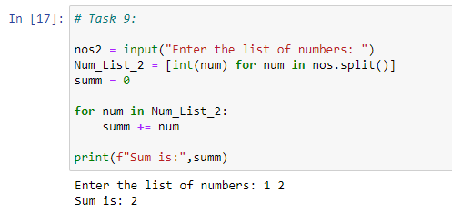
- Write a Python program to find the list of words that are longer than n from a given list of words.
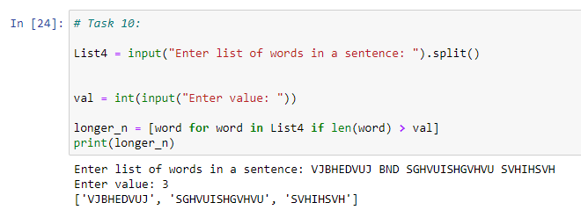
- Write a Python program to compute the difference between two lists.
Sample data: ["red", "orange", "green", "blue", "white"], ["black", "yellow", "green", "blue"]
Expected Output:
Color1-Color2: ['white', 'orange', 'red']
Color2-Color1: ['black', 'yellow']
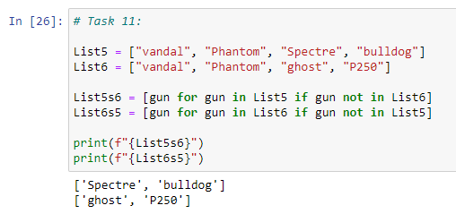
- Write a Python program to concatenate elements of a list.
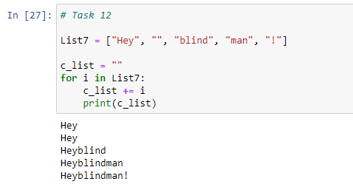
- Write a Python program to insert a given string at the beginning of all items in a list.
Sample list : [1,2,3,4], string : emp
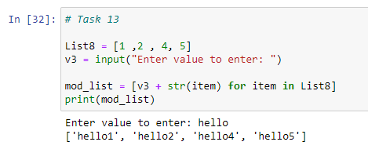
Expected output : ['emp1', 'emp2', 'emp3', 'emp4']
- Write a Python program to find the list in a list of lists whose sum of elements is the highest.
Sample lists: [1,2,3], [4,5,6], [10,11,12], [7,8,9]
Expected Output: [10, 11, 12]
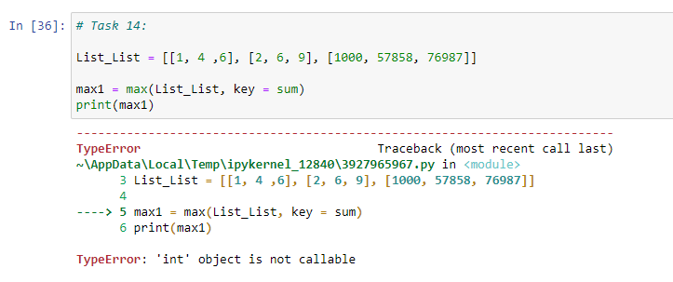

PART B
(PART B: TO BE COMPLETED BY STUDENTS)
(Students must submit the soft copy as per following segments within two hours of the practical. The soft copy must be uploaded on the Teams or emailed to the concerned lab in charge faculties at the end of the practical in case the there is no Black board access available)
Roll No. E041 | Name: Shayan Mandrekar
Program: BTI | Division: E
Semester: III | Batch : 2
Date of Experiment: 2nd jan 2024 | Date of Submission: 2nd jan 2024
Grade :

B.1 Software Code written by student:
(Paste your Python code completed during the 2 hours of practical in the lab here)

B.2 Input and Output:
(Paste your program input and output in following format. If there is error then paste the specific error in the output part. In case of error with due permission of the faculty extension can be given to submit the error free code with output in due course of time. Students will be graded accordingly.)

B.3 Conclusion:
(Students must write the conclusion as per the attainment of individual outcome listed above and learning/observation noted in section B.1)

